COVID-19 Impact Assessment:A South Asian

Perspective

Aryan Sood   
Bennett University  
Greater Noida-201310  
aryansood38@gmail.com

Shruti Pathak  
Bennett University  
Greater Noida-201310shrutipathak144@gmail.com

line 1: 3rd Given Name Surname  
line 2: *dept. name of organization   
(of Affiliation)*  
line 3: *name of organization   
(of Affiliation)*line 4: City, Country  
line 5: email address or ORCID

*Abstract*—This study examines the economic impact and public sentiment surrounding COVID-19 in 10 South Asian countries, utilizing diverse analytical approaches including epidemiological analysis, demographic profiling, and climatic examination. Analyzing the data taken from the reliable sources, the research employs advanced techniques such as the LSTM model and Multiple Criteria Decision Making (MCDM) methodologies to discern trends and patterns in the data. The analysis reveals insights into the epidemiological dynamics, demographic vulnerabilities, and climatic influences shaping COVID-19 progression. By employing a multi-faceted analytical framework, the study underscores the importance of understanding the pandemic's complexities. The findings can inform evidence-based policy interventions and strategic decision-making processes to mitigate the pandemic's impact and facilitate regional recovery efforts. Overall, this research aims to provide a thorough understanding on the COVID-19 situation in South Asia and shed light on the effectiveness of different analytical approaches in displaying the complexities of the pandemic.[1]

Keywords—COVID-19 pandemic, South Asian countries, Economic impact, public sentiment, Analytical approaches, multi-faceted framework, Climate

# Introduction

The COVID-19 pandemic has impacted all around the globe, especially in South Asia, which is a densely populated region with vivid diversification. This study aims to focus on the impact of COVID-19 in various South Asian countries based on various metrics, examining geographical variations and the influence of various government policies, public health measures, geographical measures, and socioeconomic disparities. This research seeks insights into effective pandemic responses by comparing South Asia’s experience to other regions. This analysis believes in going beyond immediate impacts, keeping the long-term consequences for healthcare systems and socio-economic landscapes. Moreover, we aim to contribute knowledge that informs future public health anticipation in South Asia.

# Literature Review

## What is COVID-19?

The COVID-19 pandemic, caused by the novel coronavirus SARS-CoV-2, has been regarded as one of the major global health crises in recent history, originated in Wuhan, China, in December 2019, the virus spread rapidly in the whole world, which led to trailblazing public health and socioeconomic impacts. COVID-19 generally spreads through respiratory droplets, making person-to-person transmission rampant, with symptoms generally comprising mild respiratory illness to acute pneumonia, organ failure, and death. Governments of every country implemented various types of containment measures, including lockdowns, travel restrictions, social distancing, and obligations to masks while traveling outside. However, the highly contagious nature of the virus and its subclinical spread posed a major challenge to containment efforts.

The pandemic stunned the healthcare systems of countries all Asian countries, leading to a shortage of medical supplies, hospital beds, and healthcare personnel. Moreover, the socioeconomic outcomes have been pro-founded, with widespread loss in employment, closure of organizations, and disruptions to education.

Efforts to combat the pandemic comprise of development and deployment of vaccines, collaborations among scientists and researchers, and ground breaking strategies. Despite vaccination efforts, new variants continued to emerge over time and posed various challenges to the government.

## Understanding the Structure of the SARS-CoV-2 Virus

COVID-19 caused by the SARS-CoV-2 virus, is an enveloped, single-stranded RNA virus that belongs to the family of Coronaviridae. Its structure comprises four main structural proteins: spike (S), envelope (E), membrane (M), and nucleocapsid (N). The S protein arbitrates viral entry into the host cell by binding to the angiotensin-converting enzyme 2 (ACE2) receptor. The viral envelope comprises S, E, and M proteins, while the N protein embodies the viral RNA genome. Deep analyses of the structure are important for developing diagnostic, tests, vaccines, and therapies to tackle the COVID-19 pandemic. Whole-genome sequencing (WGS) of SARS-CoV-2 can address certain polymerase chain reaction (PCR) based diagnostic limitations, and additionally describe the speciﬁc SARS-CoV-2 variant, or when applied across larger populations of isolates, also inform transmission or evolutionary dynamics.[2]

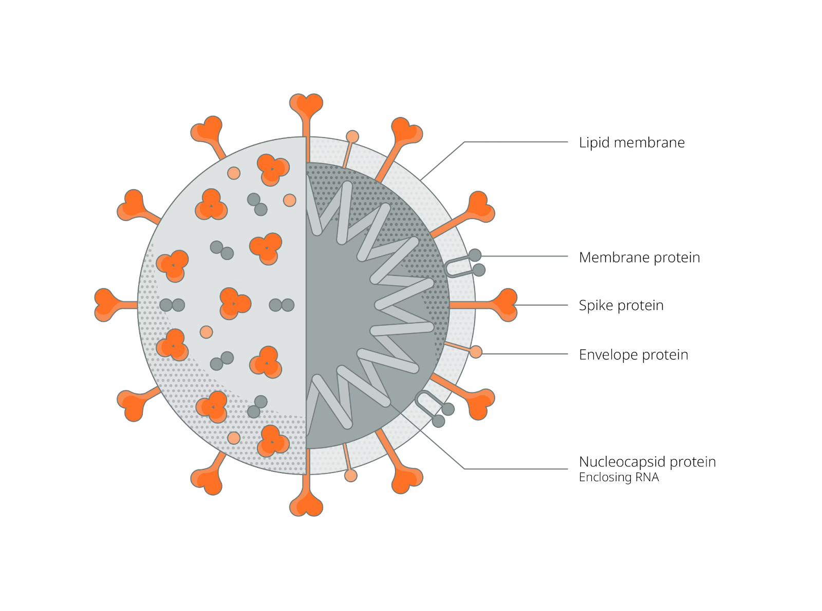

Fig.1 **Structure of COVID-19 Virus**

## The Emergence and Spread of COVID-19: Initial Observations and Temporal Dynamics

The first observation of a COVID-19 case occurred in Wuhan, China where a group of pneumonia cases with unknown etiology was reported to the nearest hospitals. Early confirmed cases of COVID-19 were speculated to have had contact history with a seafood market in Wuhan.[3] Soon, human-to-human transmission was revealed through detection of infection in at least one household cluster and in health workers caring for COVID-19 patients.[3] After initial observations, it was concluded that the outbreak occurred at a seafood market, suggesting zoonotic transmission from animals to humans. However, the virus rapidly spread across the borders of Wuhan, which lead to a global pandemic.  
With time, the spread of COVID-19 followed a trajectory of rapid growth, with cases multiplying rapidly across the whole continent. Various factors, including population density, travel restrictions, public health interventions, and societal behaviors swayed the virus transmission dynamics.

With the passage of the pandemic, different variants of infection started to develop in different regions. This was in influenced by various factors such as seasons, demographics, and the effectiveness of control measures of the particular country.

## The Spread of COVID in Asian Countries

The spread of COVID-19 in South-Asian countries can be enhanced due to various factors including population density, travelling, and initial miscalculation of the seriousness of the virus. In various highly populated areas like China, India, and various South-Asian countries, the virus found various ways for transmission across a specific region. However, continuous travelling was regarded as the major reason for the spread of the virus from its core in Wuhan, China, to various countries and beyond.

In the initial stages of the pandemic, various Asian countries struggled to timely detect, contain and examine the harmful effects of the virus. This delay in transmission allowed for community transmission at a very fast pace. Various cultural factors such as population mobility for work, religious gatherings, and population further intensified the spread.

However, many Asian countries acted rapidly through the swift implementation of various measures, mass testing, contact tracing, and public health measures. Therefore, alongside various types of vaccination campaigns and many other effective measures to control the spread of COVID-19 in a particular region.

## Cultural Factors Contributing to the Spread of COVID-19

In South Asian countries, several cultural factors were responsible for the spread of COVID-19:

1. Social Gatherings:  
   South Asian cultures generally comprise large social gatherings, religious practices, and offerings. Various types of events such as weddings, and festivals like Diwali, and Eid were considered as the ideal conditions for the rapid spread of the virus due to close contact among a very large group.
2. Focus on Multigenerational Households:  
   A lot of South Asian households follow the concept of an extended family structure where more than one generation tends to live together under one roof. This concept increases the risk of transmission within households, as a single infected person can spread the virus to a large group in very little time. In this case, the elderly people in the family are more prone to severe illness.
3. Population Concentration:  
   Metropolitan areas in South Asia are often heavily populated, leading to congestion in public places, transportation, and residential areas. This saturation nurtured the rapid spread of the virus, making it difficult to maintain physical distancing measures.
4. Lack of Healthcare Access:  
   In many South Asian countries, a substantial portion of the population relies on unconventional employment with restricted access to healthcare. This scenario led to various challenges in establishing various preventive measures and accessing medical care, further intensifying the spread of the virus in the nation.
5. Social and Personal Hygiene:  
   Various cultural practices such as community gatherings, sharing utensils, and very little emphasis on personal hygiene in some contexts also played a major role in the spread of COVID-19 by fostering the transmission through contaminated surroundings and respiratory droplets.

## Impact of Public Health Responses in the spread of COVID-19

Public Health responses are considered to be a major factor in reducing the spread of COVID-19 in South Asian countries. Limitations such as early detection of the virus, rapid testing, contact monitoring, and quarantine protocols have played a major role in containing the spread and controlling the community transmission of the disease. Also, various public health campaigns like fostering mask-wearing, hand hygiene, and social distancing have aggravated awareness and inspired various preventive behaviors. Still, various challenges such as limited healthcare infrastructure, socio-demographic disparities, and effective distribution of vaccine gaps have influenced the effectiveness of these responses. Overall, proactive public health interventions remain necessary in controlling the spread of COVID-19 and reducing its impact in South Asian countries.

## Weather Patterns and the Spread of COVID-19 in South Asian Countries

Weather plays a major role in influencing the spread of COVID-19 in South Asian countries. While initial observations prove that warmer temperatures and an increase in humidity might control the transmission of the virus, the true impact of weather on the transmission has been complex. In South Asia, where the climate ranges from tropical to subtropical, season variations affect social interactions, population movement, and healthcare foundation.

During the summer and more humid months, people prefer spending more time in their homes with air conditioning, possibly elevating the risk of indoor transmission. On the other hand, monsoon seasons might lead to overcrowding and increase the vulnerability to various respiratory infections. Our results are consistent with the hypothesis that heat and sunlight reduce the spread of SARS-CoV-2 and the prevalence of COVID-19, which was also suggested by most of the previous studies examining the same

hypothesis with different data and approaches.[4] Moreover, extreme weather events, such as floods and cyclones can hinder healthcare services and aggravate vulnerabilities, impacting the pandemic response.

## Economic Structure's Influence on COVID-19 Spread in South Asian Countries

The economic structure of South Asian countries, distinguished by a major informal sector, dense urban populations, and a focus on labor-intensive industries, has affected the spread of COVID-19. As the disease containment measures became increasingly stringent by mid-March 2020, the disruption of supply chains and slowing of economic activities became drastic.[5] However, a significant decline in worldwide economic growth was already noted even before COVID-19, mainly due to the trade war between China and the United States and the steep decline in consumer expenditure.[5] Informal workers faced various challenges and difficulties in complying with different preventive measures due to unstable employment conditions, leading to an increase in transmission. Moreover, densely populated urban areas and dependence on public transportation orchestrated the spread of the virus.

A lot of different industries like textiles, manufacturing, and automobiles often work in crowded workplaces, and confinement to healthcare played a major role in the spread of the pandemic. The fragility in the economic structures of various countries underlined the importance of focused measures to protect the population and alleviate transmission in South Asian countries.

## Lessons Learned and Challenges Faced During the COVID-19 Pandemic Across South Asian Countries

### India

Lessons Learned: Implementation of sturdy healthcare infrastructure, rapid development of vaccines, and the requirement for streamlined response strategies.

Challenges faced: Stiff healthcare system, difficulties in the distribution of vaccines and controlling the spread of fake news.

### China

Lessons Learned: Detection of the virus at early stages and adamant measures are responsible for containing the virus. Also, investment in public health infrastructure and global cooperation are crucial as well.

Challenges Faced: Spread of false news in early stages, international inspection, and managing asymptomatic cases.

### Russia

Lessons Learned: Accelerating the development of vaccines, counterbalancing various public health measures alongside civil independence, and the necessity of public communication.

Challenges Faced: Efficient allocation of vaccines, economic impacts, and spread of misleading information.

### Bangladesh

Lessons Learned: Refining the healthcare systems, strengthening the collection of data for fast decision-making, and ameliorating social safety nets.

Challenges Faced:  Restrained healthcare capacity, economic disturbance, and vaccine acquirement challenges.

### Pakistan

Lessons Learned: Necessity of community awareness, refining healthcare infrastructure, and efficient control of the spread of misinformation.

Challenges Faced: Weak healthcare system, anti-vaccinationism, and social structure on exposed populations.

### Sri-Lanka

Lessons Learned: Receptivity to pandemics, refining the surveillance systems, and the importance of timely decision-making.

Challenges Faced: Sturdiness in the healthcare system, economic instability, and balancing public health measures alongside the economic needs of the country.

### Phillipines

Lessons Learned: Improving the healthcare infrastructure, upgrading pandemic readiness, and the importance of international cooperation.

Challenges Faced: Over-stressed healthcare system, economic instability, and vaccine acquisition challenges.

### Afghanistan

Lessons Learned: Afghanistan learned the critical importance of rapid response, healthcare strengthening, and overcoming vaccine distribution hurdles.

Challenges faced: Overstretched healthcare resources, profound economic downturns, and deep-seated vaccine hesitancy across its population.

### Japan

Lessons Learned: Importance of early-stage quarantine measures, investment in public health framework, and flexible response strategies.

Challenges Faced: Balancing public health measures with economic concerns, managing COVID-19 variants, and effective vaccine distribution challenges.

### Indonesia

Lessons Learned: Necessity of early phase detection and quarantine measures, improving the healthcare of the country and tackling the distribution of vaccines.

Challenges Faced: Issues in the healthcare system, economic instability, and addressing the issue of vaccine hesitancy.

## Impact of COVID-19 on the Education Sector in South Asian Countries

COVID-19 had a drastic effect on the Education and learning sector around the world which has led to major turmoil in the education sector. The closure of schools all around the continent was implemented to control the spread of the virus. This ultimately resulted in more than 1 crore students using the online means of communication for attaining education. Also, the online conversion led to various challenges like access to technology, unavailability of internet services in the rural regions, and the digital divide disproportionately affected various depreciated communities, widening the gap between the current education diversity. Moreover, the closure of schools and other educational institutions befuddled the academic calendars, postponed examinations, and hindered different activities. In spite of various efforts to adapt the online mode of education and distance learning programs, the quality of education suffered at a detrimental rate, and various concerns came into existence regarding the efficiency of remote teaching methodologies. As countries got used to the reopening of schools safely and addressing learning loss, the pandemic shed light on the urgent need for digital infrastructure, teacher training, and innovative educational approaches to ensure continued access to quality education for all South Asian students.

# Research Methodology

## Time Series Analysis

Time series analysis is a statistical technique that is used to examine sequential data points collected over a period of time. It is normally used in various fields such as weather forecasting, entertainment, finance, stock markets, economics, and signal processing. The major aim of Time Series Analysis is to understand various patterns, trends, and behaviors inside the data to make various predictions or derive various insights. The major parts comprise trend analysis, which focuses on long-term changes, seasonality analysis, which focuses on different patterns within a specific time frame, and cyclical analysis, which explores fluctuations not tied to seasonal variations. Different techniques like moving averages, Long Short-term memory (LSTM) models, and various machine learning algorithms are generally used for future forecasting values or analyzing different patterns. Time Series Analysis is necessary in making informed and calculated decisions based on historical data in dynamic systems.

### LSTM

Long Short-Term Memory (LSTM) is a type of Recurrent Neural Network (RNN) architecture that is designed to handle sequence prediction problems, particularly in scenarios where long-term dependencies are crucial. In comparison to traditional RNNs, LSTM networks are stocked with memory cells that can handle information over long periods, allowing them to capture and learn from sequential data more effectively. The formula for the LSTM cell update is as follows.

Fig 2. **Formula for LSTM**

where \(x_t\) is the input at time step \(t\), \(h_t\) is the output at time step \(t\), \(c_t\) is the cell state at time step \(t\), \(i_t\), \(f_t\), and \(o_t\) are the input, forget, and output gates respectively, \(\sigma\) is the sigmoid activation function, and \(\text{tanh}\) is the hyperbolic tangent activation function. \(W\) and \(b\) are the weights and biases of the gates, respectively. Several other studies share the use of simple or multiple regression models, sometimes including quadratic or cubic terms for the climatic variables involved in the model.[6] LSTM is superior to the traditional Recurrent neural network (RNN) in term of its good enactment in apprehending the long-term dependency of sequences, thus being appropriate for the categorization, processing, and forecasting the long sequence data.[7]

LSTM’s potential to handle vanishing and exploding gradients makes it most effective for tasks such as NLP, speech recognition, and time series prediction. Time series (TS) data is the information gathered over regular time intervals such that every data point is evenly spaced over time. Time series analysis is most productive when utilized in transient estimating.[8] It is the method of predicting future patterns/trends of a certain event with temporal characteristics.[8] To forecast the transmission of coronavirus, it can be productive if provided information has temporal components and it is different from conventional regression schemes.[8] A time series information may be divided into trend, error, and seasonality.[8]

## MCDM

Multi-Criteria Decision Making (MCDM) is a methodology used to analyze and rank alternatives based on multiple criteria or objectives. It’s employed in various fields such as engineering, business, and environmental science, where decisions involve trade-offs between various conflicting objectives. The whole procedure generally comprises several steps including identifying criteria, defining alternatives, assigning weights to criteria, and applying decision-making techniques to generate a ranking.

One widely used technique in MCDM is the Analytic Hierarchy Process (AHP), introduced by Thomas L. Saaty. AHP gives a methodical approach to tackling complex decision problems by decomposing them into a hierarchical structure of criteria and alternatives. The formula for AHP can be expressed as follows:

Fig 3. **Formula for MCDM**

Where \( w_{ij} \) represents the weight of criteria \( i \) with respect to criteria \( j \), and \( a_{ij} \) denotes the pairwise comparison between criteria \( i \) and \( j \), usually represented in a comparison matrix.

MCDM techniques like AHP pave the way for transparent and structured decision-making processes, allowing decision-makers to make calculated choices that match their objectives and preferences.

### Hierarchical Clustering Analysis and Predictive Severity Assessment of COVID-19 Impact in South Asian Countries

The given dendrogram provides a hierarchical clustering of South Asian nations based on their COVID-19 responses and impacts, using Multi-Criteria Decision-Making (MCDM) analysis. While the dendrogram illustrates the similarities among the different countries through varying merges, it lacks transparency regarding different criteria and their weights. Conversely, the Severity Ranking table predicts severity scores, providing insights into the pandemic’s potential implications. Moreover, the precise relationship between these dendrogram and severity scores remains undefined. Various possible factors such as varying criteria subsets, weight allocations, or disparate data sources may contribute to this ambiguity. Integrating these insights shall allow a refined understanding of regional pandemic dynamics, making the way for evidence-based policy formulation and strategic interventions to moderate COVID-19 impact effectively.

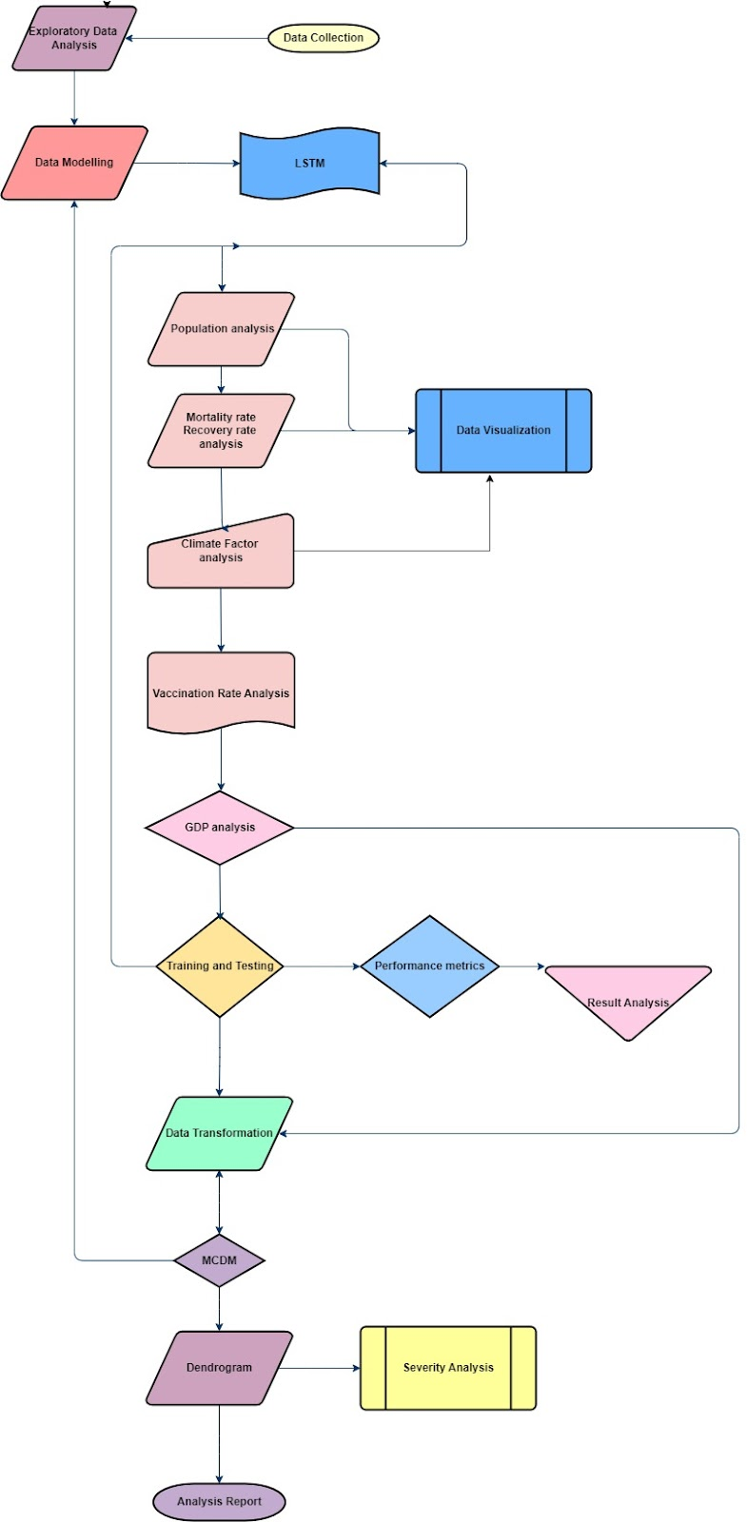

Fig 4. **Research Methodology Flow Chart Diagram**

# Observation

The aim of this section is to understand and showcase the impact of vaccination speed on the final control of COVID-19 by analyzing the time needed to vaccinate 60% of the population of every country.[9] Successful practices in China show that case identification and management, coupled with close contact tracing and isolation, is a powerful strategy.[10] The lessons of Japan and India show that social distancing is an effective measure, but only if it is rigor and persistent.[10] Finally, in both developed and developing countries, the development of health care systems and coordinated government leadership play a key role in overcoming epidemics.[10]

## Impact of COVID on GDP

All the countries experienced a major change in the GDP due to the COVID-19 pandemic. COVID-19 has slowed down economic activities, led to a temporary shut-down of industrial activities, closing of schools and a range of public institutions affecting millions of students and significantly reduced air travel and human mobility worldwide.[11] Depending upon their economic stability and healthcare system they were able to tackle the impact of GDP on themselves as shown in the figure. This change is displayed in varying degrees, with some nations showing positive growth. While others displayed a major decline in their GDP.

China stands out as the only country that experienced a positive growth in GDP after the COVID-19 pandemic. China’s rigid containment measures, alongside robust manufacturing capabilities and government stimulus, resulted in an astonishing growth of 5.40% in its GDP. Whereas, India, Bangladesh, Pakistan, Indonesia, the Philippines, and Sri Lanka faced a major decline in their respective GDP levels ranging from -1.20% to -17.60%, displaying major economic contraction resulting from the pandemic-induced disruptions.

Among all these countries, Pakistan suffered the most substantial decrease in GDP levels because of the pandemic. In comparison to that, Japan and Russia saw minor declines of -1.20% and -2.40%, respectively, displaying comparatively stable economic conditions despite the adverse effects of the pandemic.

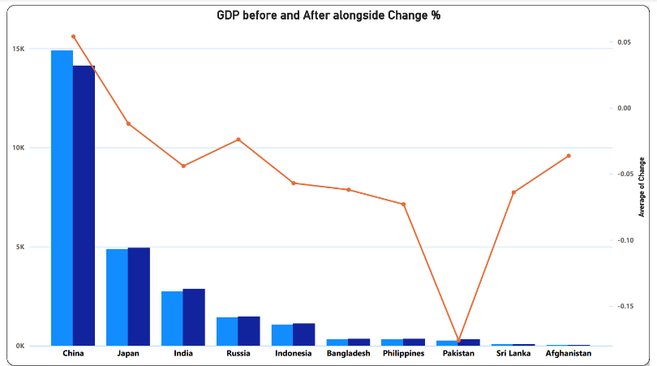

Fig 5. **Change in GDP graph**

The GDP of China stands out with an astonishing 5.40% change post-COVID-19, contrasting severely with negative trends in other countries like Japan, India, and Russia. The sturdy economic rebound of China can be due to various reasons like rapid containment measures, aggressive fiscal policies, and a focused resilient manufacturing sector. The country’s rigid domestic demand alongside effective government policies, sustained consumer spending and investment. Moreover, China’s emphasis on technological advancement and digitization further fueled economic growth, allowing it to adapt to the rapid change in the market. This enthusiastic approach made China a global financial leader, displaying resilience amid unprecedented challenges.

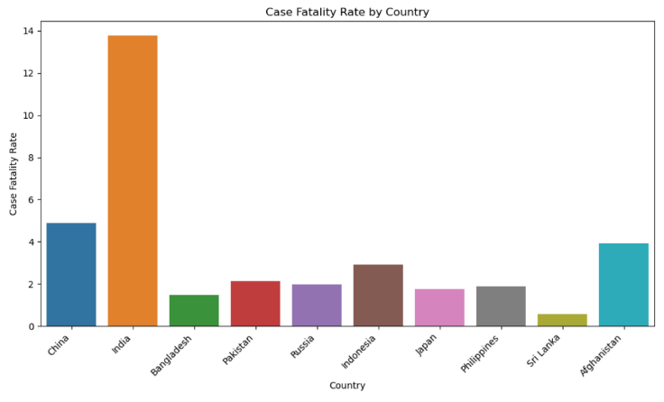

Fig 6. **Case Fatality Rate by Country Graph**

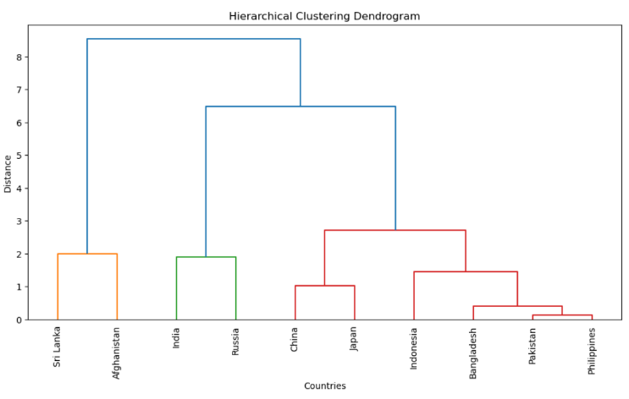

Fig 7. **Dendrogram Diagram**

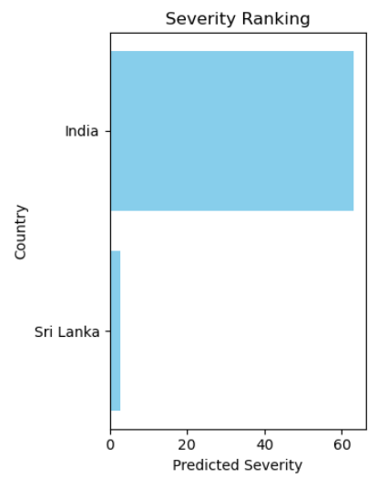

Fig 8. **Severity Ranking of Countries**

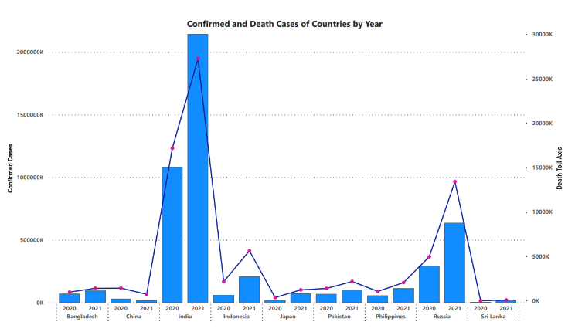

Fig 9. **Confirmed and Death Case Comparison of Countries**

India recorded the highest fatality rate in terms of COVID cases and Sri Lanka the lowest, it's very clear from the data that the most populous country recorded the highest fatality rate, unlike the country with the least population. It becomes challenging in areas where there is dense population to implement physical distancing measures and hence the risk of virus transmission increases.

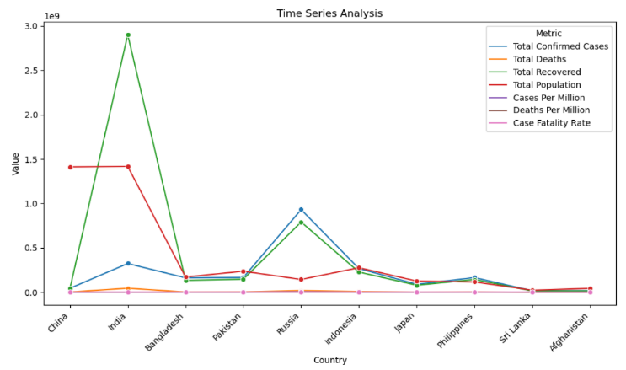

Fig 10. **Time Series Analysis of Every Country**

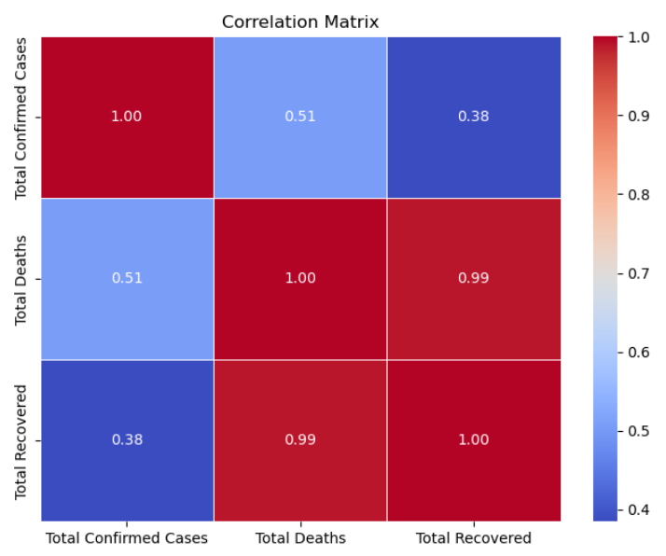

Fig 11. **Correlation Matrix**

## Vaccination Trends

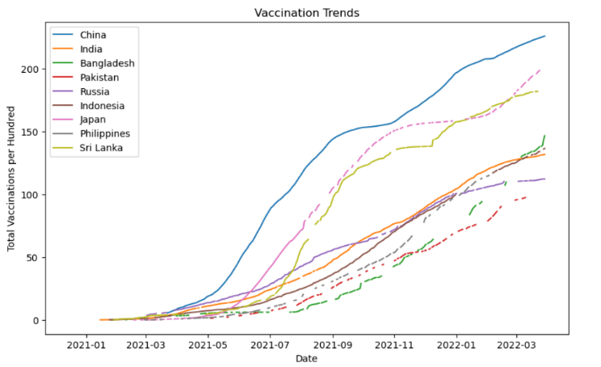

Fig 12. **Vaccination Trend Among Countries**

China was the first country to develop and approve vaccination and not just manufacturing they had sound healthcare management so they implemented vaccines at a high rate. Moreover, China’s previous experiences with H1N1 and SARS can be the main reason for its proactive response to the COVID-19 pandemic.

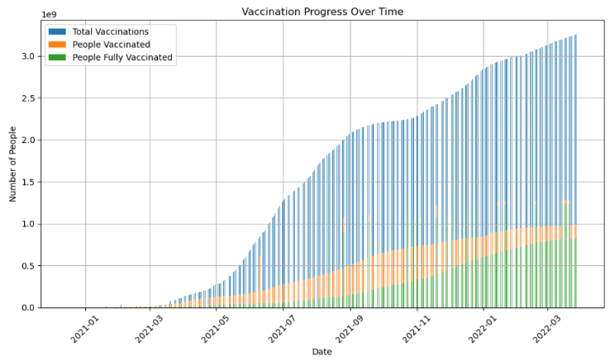

Fig 13. **Vaccination Progress over time**

This graph shows that vaccination trends increased over time, the reasons responsible for this can be the fact that government invested and also the health organizations might have invested in vaccine manufacturing. Vaccination campaigns and awareness increased in people about myths and false information about vaccines that they may cause harm.

## Distribution of Active Cases across Different Climates

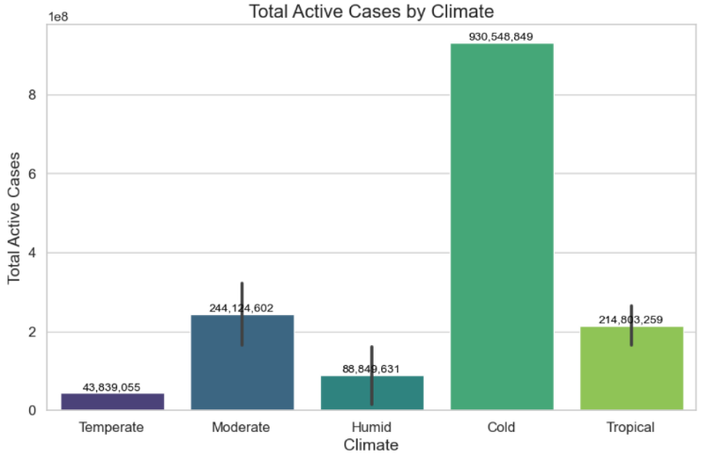

Fig 14. **Distribution of Cases by Climate**

It can be observed that an extreme number of cases are recorded in cold climates, one of the major reasons could be that the COVID-19 virus present in respiratory droplets evaporates slowly in drier air caused by cold weather.

## Confirmed Cases over Time

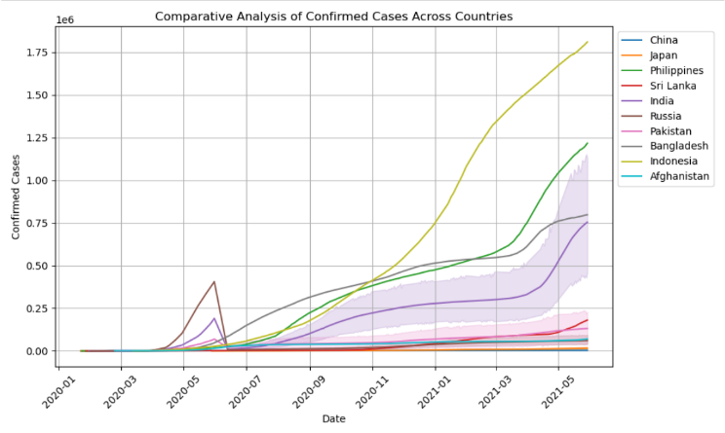

Fig 15. **Confirmed Cases over time across Countries**

Indonesia has had an immense impact on COVID-19 spread among all other countries. One of the major reasons can be its geographical location. Indonesia consists of several islands which makes it challenging to implement public health measures effectively and to distribute uniform healthcare resources and necessary facilities across the country.

## LSTM

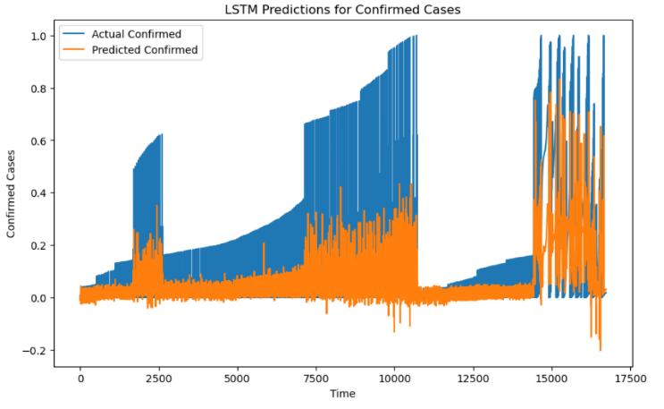

Fig 16. **LSTM Prediction for Confirmed Cases**



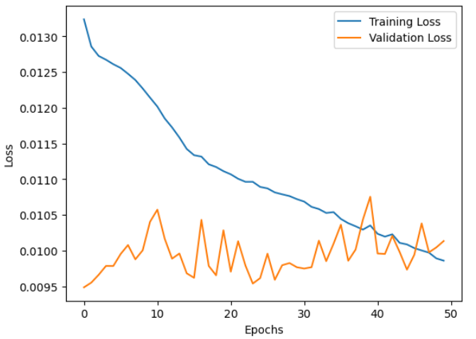

Fig 17.  **Training and Validation Loss**

## Trend Analysis

In the four graphs below it is easily understandable that among all of them, India is the only country that experienced a major rise in the total number of confirmed cases in 2021. However, the other countries were able to fight against the second wave of COVID due to their strict measures and restrictions. They accepted these methods because of the learnings during the first wave. The major reason India suffered such a major drawback is because of the large amount of population as compared to other countries and thereby it proved to be a major hindrance to the country’s ability to control the transmission and spread of the virus.

### India

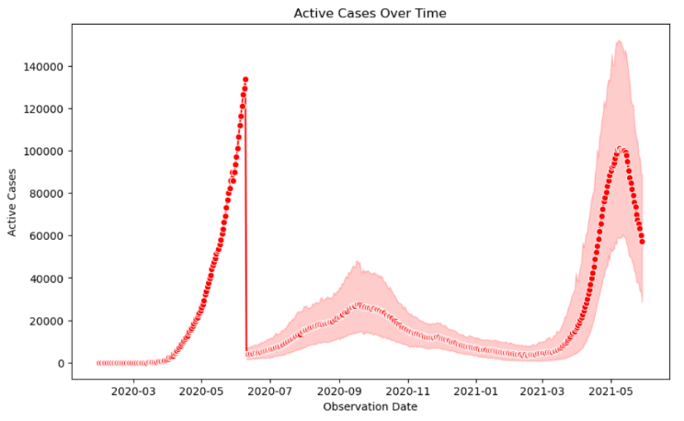

Fig 18.  **Active Cases over Time in India**

### China

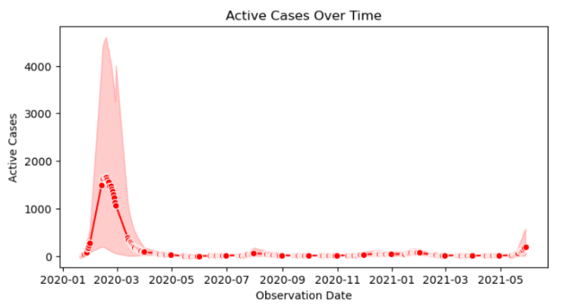

Fig 19.  **Active Cases over Time in China**

### Japan

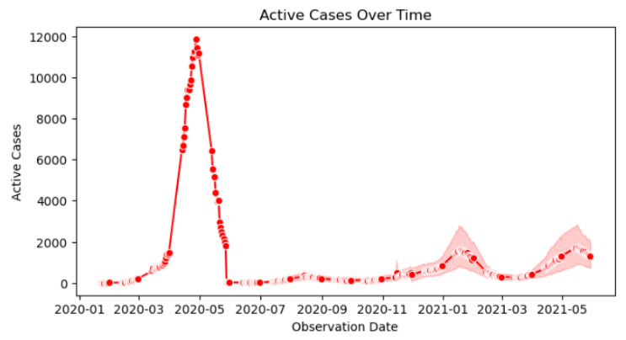

Fig 20.  **Active Cases over Time in Japan**

### Russia

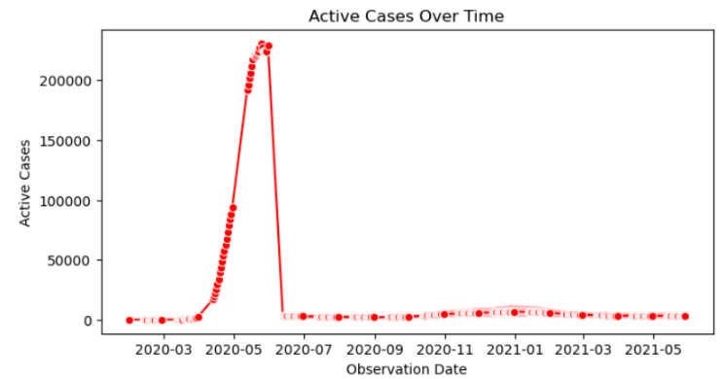

Fig 18.  **Active Cases over Time in Russia**

# Discussion

The research paper's findings focus on several essential factors influencing the spread, impact, and consequences of COVID-19 in South Asian countries. India's distinctive issues, such as its large population and initial challenges in curbing disease transmission, emphasize the significance of well-implemented public health resources and strategies and early actions. The growing vaccination trends emphasize favorable results from initiatives taken by the government and enhanced public understanding, addressing vaccine skepticism, myths, and false information.  
Indonesia's geographical intricacy presents a challenging barrier to uniform healthcare distribution, worsening COVID-19 spread. The correlation between population density and fatality rates, embodied by India and Sri Lanka, highlights the importance of tailored remedies in highly densely populated regions. Meanwhile, China's strong GDP amid global decline underscores its effective confinement measures and quick economic recovery strategies. China's proactive tactic and approach, coupled with sturdy healthcare infrastructure and rigorous control measures, likely added to its economic resilience in disparity to other impacted nations. These insights emphasize the multi-dimensional nature of COVID-19 impacts, requiring sophisticated policy responses adapted to each country's unique environmental scenarios.  
Apart from the surveillance referenced in the research paper, it's crucial to examine and investigate the reasons why certain countries, like Japan, with geographical challenges similar to Indonesia, have not experienced as severe repercussions from COVID-19. Japan's relatively lesser impact, despite its island-based geography, can be ascribed to several noteworthy factors.  
Japan's potent healthcare system and capable governance have considerably restrained the virus's spread. The country's cutting-edge healthcare infrastructure, coupled with proactive examination and testing, contact tracing, and separation measures, have enabled early detection and containment of severe outbreaks, reducing the spread of COVID-19.

# Conclusion

In the end, we can conclude that the COVID-19 pandemic has given many unparalleled challenges for children and adolescents, especially in their mental and physical health.[1]Various methods were implemented by the governments, like contact restrictions, lockdowns, and social distancing, which majorly impacted the social environment worldwide. At the same time, these measures could threaten the mental health of individuals, they also provide the chance for personal growth and empathy towards the family. Still, the disadvantages overshadow the benefits, with anxiety, lack of contact with the outside environment, and fewer chances for stress regulation being vital concerns. Moreover, the pandemic has also aggravated the children and adolescents who were already at a disadvantage or marginalized.[1]

The pandemic can be categorized into three segments: preparation, punctum maximum, and return to normality.[1] Each phase tends to represent a unique psychological reaction and challenge for medication and analysis of the effect of COVID-19 on an individual. At this stage, the impact of the government becomes vital to make sure the care of everyone during all phases, while putting more emphasis on the weaker sections of the society. Based on several statistical assessments, the forecasting performance was similar for the conﬁrmed, recovered, and death cases with shallow variance errors.[12]

Thorough research was required to understand the allusions of policies required to contain the pandemic on mental health and to analyze the risk ratio of measures on the children. By working alongside each other we can make sure to neutralize the impact of the pandemic on the mental and physical health of the children and adults. Further evaluation of the origin and settings of the articles revealed a wide gap between the South Asian countries in the context of their contribution to the body of research related to COVID-19.[13]

##### Acknowledgment

We would like to express our heartfelt gratitude to our mentor **Dr. Yajnasneni Das, Assistant Professor SCSET, Bennett University, India** who has guided us throughout

our study for this research paper. Her guidance has helped us draw insights and inferences from our study. We also want to thank everyone who make this dataset available on the web for us to use. We would also like to express our special thanks to our fellow members who have put in their efforts to guide us through their suggestions for improvement in our study. Finally, we want to extend our gratitude and appreciation to our faculty for their patience and encouragement during the research paper which inclined the development of this research paper.

##### References

[1] J. M. Fegert, B. Vitiello, P. L. Plener, and V. Clemens, “Challenges and burden of the Coronavirus 2019 (COVID-19) pandemic for child and adolescent mental health: A narrative review to highlight clinical and research needs in the acute phase and the long return to normality,” *Child and Adolescent Psychiatry and Mental Health*, vol. 14, no. 1. BioMed Central, May 12, 2020. doi: 10.1186/s13034-020-00329-3.

[2] S. R. Mziray *et al.*, “Whole-genome sequencing of SARS-CoV-2 isolates from symptomatic and asymptomatic individuals in Tanzania,” *Front Med (Lausanne)*, vol. 9, Jan. 2023, doi: 10.3389/fmed.2022.1034682.

[3] H. Xu *et al.*, “Possible environmental effects on the spread of COVID-19 in China,” *Science of the Total Environment*, vol. 731, Aug. 2020, doi: 10.1016/j.scitotenv.2020.139211.

[4] S. Chen *et al.*, “Climate and the spread of COVID-19,” *Sci Rep*, vol. 11, no. 1, p. 9042, Apr. 2021, doi: 10.1038/s41598-021-87692-z.

[5] P. R. Jena, R. Majhi, R. Kalli, S. Managi, and B. Majhi, “Impact of COVID-19 on GDP of major economies: Application of the artificial neural network forecaster,” *Econ Anal Policy*, vol. 69, pp. 324–339, Mar. 2021, doi: 10.1016/j.eap.2020.12.013.

[6] Á. Briz-Redón and Á. Serrano-Aroca, “The effect of climate on the spread of the COVID-19 pandemic: A review of findings, and statistical and modelling techniques,” *Prog Phys Geogr*, vol. 44, no. 5, pp. 591–604, Oct. 2020, doi: 10.1177/0309133320946302.

[7] S. G. Fard, H. M. Rahimi, P. Motie, M. A. S. Minabi, M. Taheri, and S. Nateghinia, “Application of machine learning in the prediction of COVID-19 daily new cases: A scoping review,” *Heliyon*, vol. 7, no. 10, Oct. 2021, doi: 10.1016/j.heliyon.2021.e08143.

[8] H. T. Rauf *et al.*, “Time series forecasting of COVID-19 transmission in Asia Pacific countries using deep neural networks,” *Pers Ubiquitous Comput*, vol. 27, no. 3, pp. 733–750, Jun. 2023, doi: 10.1007/s00779-020-01494-0.

[9] M. Baniasad, M. G. Mofrad, B. Bahmanabadi, and S. Jamshidi, “COVID-19 in Asia: Transmission factors, re-opening policies, and vaccination simulation,” *Environ Res*, vol. 202, Nov. 2021, doi: 10.1016/j.envres.2021.111657.

[10] X. Wang *et al.*, “A Comparative Retrospective Study of COVID-19 Responses in Four Representative Asian Countries,” *Risk Manag Healthc Policy*, vol. 15, pp. 13–25, 2022, doi: 10.2147/RMHP.S334326.

[11] “The Impact and Policy Responses for COVID-19 in Asia and the Pacific.”

[12] A. I. Shahin and S. Almotairi, “A deep learning BiLSTM encoding-decoding model for COVID-19 pandemic spread forecasting,” *Fractal and Fractional*, vol. 5, no. 4, Dec. 2021, doi: 10.3390/fractalfract5040175.

[13] “COVID-19 research in South Asia: a bibliometric analysis of the 100 most-cited articles COVID-19 Forschung in Südasien: eine bibliometrische Analyse der 100 meist zitierten Artikel.”

**IEEE conference templates contain guidance text for composing and formatting conference papers. Please ensure that all template text is removed from your conference paper prior to submission to the conference. Failure to remove template text from your paper may result in your paper not being published.**

We suggest that you use a text box to insert a graphic (which is ideally a 300 dpi TIFF or EPS file, with all fonts embedded) because, in an MSW document, this method is somewhat more stable than directly inserting a picture.

To have non-visible rules on your frame, use the MSWord “Format” pull-down menu, select Text Box > Colors and Lines to choose No Fill and No Line.